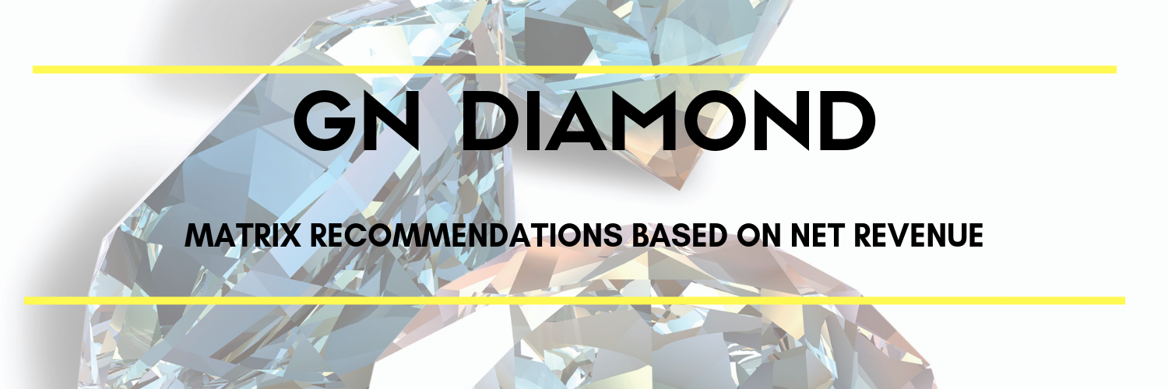
NET REVENUE OF $500k - $750k
Shape | Size | Color | Clarity | Number of Stones
Round | .50-.59 | G-H | VS2-SI1 | 1
Round | .50-.59 | D-F | SI1 | 1
Round | .50-.59 | G-H | SI1-2 | 1
Round | 0.5 ($600-$650) | Non cert |  | 1
Round | .70-.79 | D-G | VS1-2 | 1
Round | .70-.79 | D-F | SI1 | 1
Round | .70-.79 | D-H | SI2 | 1
Round | .90-.99 | D-H | SI1-2 | 1
Round | 1ct ($2500-$2700) | Non cert |  | 1
Round | 1ct | D-G | SI2 | 1
Round | 1ct | G-H | SI1 | 1
Round | 1.20-1.29 | D-H | SI1-2 | 1
Round | 1.5 | D-H | SI2-I1 | 1
Princess | 0.5 | D-G | VS1-2 | 1
Princess | .70-.79 | D-H | VS2-SI1 | 1
Princess | 1ct | D-H | VS-SI | 1
Cushion | 1ct | D-H | SI2 | 1

NET REVENUE OF $751k - $1.2m
Shape | Size | Color | Clarity | Number of Stones
Round | .50-.59 | D-F | VS1-2 | 1
Round | .50-.59 | G-H | VS1-2 | 1
Round | .50-.59 | D-F | SI1 | 1
Round | .50-.59 | D-F | SI2 | 1
Round | .50-.59 | G-H | SI1-2 | 1
Round | .50 ($600-$650) | Non cert |  | 1
Round | .70-.79 | D-G | VS1-2 | 1
Round | .70-.79 | D-F | SI1 | 1
Round | .70-.79 | D-H | SI2 | 1
Round | .90-.99 | D-H | SI1-2 | 1
Round | 1ct ($2500-$2700) | Non cert |  | 1
Round | 1ct | D-G | SI2 | 1
Round | 1ct | G-H | SI1 | 1
Round | 1.20-1.29 | D-H | SI1-2 | 1
Round | 1.5ct | D-H | SI2-I1 | 1
Princess | .50ct | D-G | VS1-2 | 1
Princess | .70-.79 | D-H | VS-SI2 | 1
Princess | 1ct | D-H | VS-SI | 1
Cushion | 1ct | D-H | SI2 | 1

NET REVENUE OF $1.201m +
Shape | Size | Color | Clarity | Number of Stones
Round | .50-.59 | D-F | VS1-2 | 1
Round | .50-.59 | G-H | VS1-2 | 1
Round | .50-.59 | D-F | SI1 | 1
Round | .50-.59 | D-F | SI2 | 1
Round | .50-.59 | G-H | SI1-2 | 1
Round | .50 ($600-$650) | Non cert |  | 1
Round | .60-.69 | D-G | VS2-SI2 | 2
Round | .70-.79 | D-G | VS1-2 | 1
Round | .70-.79 | D-F | SI1 | 1
Round | .70-.79 | D-H | SI2 | 1
Round | .90-.99 | D-H | SI1-2 | 1
Round | 1ct ($2500-$2700) | Non cert |  | 1
Round | 1ct | D-G | SI2 | 1
Round | 1ct | G-H | SI1 | 1
Round | 1.20-1.29 | D-H | SI1-2 | 1
Round | 1.30-1.49 | D-H | SI1-2 | 1
Round | 1.5ct | D-H | SI2-I1 | 1
Round | 1.50-1.59 | D-H | SI1 | 1
Round | 2ct | D-H | SI2-I1 | 1
Princess | .50ct | D-G | VS1-2 | 1
Princess | .70-.79 | D-H | VS-SI2 | 1
Princess | 1ct | D-H | VS-SI | 1
Cushion | 1ct | D-H | SI2 | 1
Cushion | 1.5ct | D-H | SI1-2 | 1

